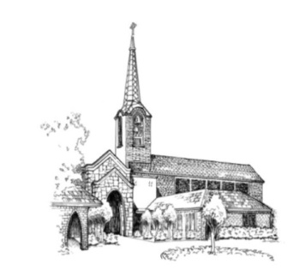
Permission Slip and Liability Release Form

To whom it may concern:

The undersigned does hereby give permission for our (my) child, ______________________________

to attend and participate in the ______________________________________________ program at First Presbyterian Church and give permission for them to ride on church vehicles and or in church members vehicles in accordance with the Child/Youth Protection Policy of First Presbyterian Church of Belmont, NC.

We (I), being 21 years of age or older, do for our selves (myself) (and for and on behalf of my child participant if said child is not 21 years of age or older) do hereby release, forever discharge and agree to hold harmless First Presbyterian Church and all the representatives thereof from any and all liability, claims, or demands for personal injury, sickness, or death, as well as property damage and expenses, of any nature whatsoever which may be incurred by the undersigned and the child-participant that occur while said child is participating in the above described trip or activity.

Furthermore, we (I) [and on behalf of our (my) child-participant if under the age of 21 years] hereby assume all risk of personal injury, sickness, death, damage and expense as a result of participation in recreation and work activities involved therein.
Further, authorization and permission is hereby given to said church to furnish any necessary transportation, food, and lodging for this participant.
The undersigned further hereby agree to hold harmless and indemnify said church, its representatives, employees and agents, for liability sustained by said church as a result of the negligent, willful or intentional acts of said participant, including expenses incurred attendant thereto.

(If the participant has not attained the age of 21 years):
We (I) are the parent(s) or legal guardian(s) of this participant, and hereby grant our (my) permission for him/ her to participate fully in said activity, and hereby give my permission to take said participant to a doctor or hospital and hereby authorize medical treatment, including but not in limitation to emergency surgery or medical treatment, and assume the responsibility of all medical bills, if any.

Known allergies are:_________________________________________________________________________

Medications taken regularly ___________________________________________________________________

Any special circumstances we should be made aware of_____________________________________________

Parent(s)/Legal Guardian Name____________________________________/Contact phone #_____________

(Parent signature) (Date)_____________________________________________________________________

(Printed name of other Emergency Contact)___________________________/Contact phone #_____________

